Gale In Context: For Educators
Blog Post
Primary Audience: Teachers

How to Use: (1) Customize the copy as needed. (2) Hyperlink to your library’s website or Gale In Context: For Educators product page. Shorten the link with Bitly, if needed. (3) Copy and paste the copy into your blog. (4) Proof and ensure the hyperlink works. (5) Post.

Save Time with Gale In Context: For Educators
Lesson planning consuming your time? Let Gale In Context: For Educators help you take it back. This all-in-one resource merges quality curriculum-aligned content with related lesson plans, activities, project plans, and instructional resources that you can use to support differentiated learning and cross collaboration. Achieve your instructional goals more easily while focusing on what matters most: keeping students engaged and motivated.
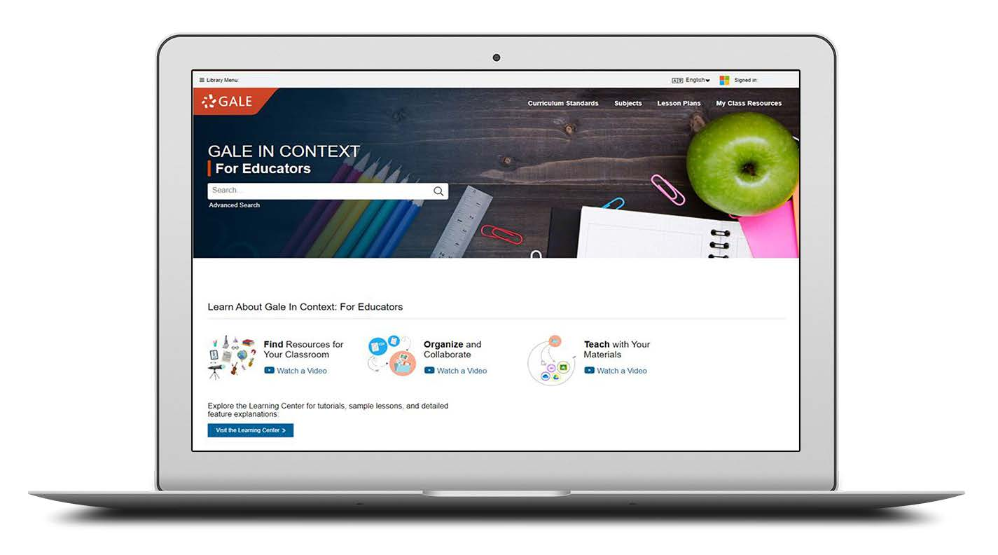

Support English language arts, literacy, science, social studies, and more with high-quality digital content, including a variety of primary sources, experiments, case studies, academic journals, magazines, newspapers, books, images, podcasts, and videos. With tools like language translation, ReadSpeaker, and the OpenDyslexic font, learning is made accessible for all students.

Want to explore how you can better use this instructional tool to collect, organize, customize, and share classroom instructional materials? Access Gale In Context: For Educators now at <hyperlink to your library’s website or Gale In Context: For Educators product page>. Ask me if you need the username and password and/or additional help getting started.

<Librarian’s Name>
<Title>
<School>

